The Influence of Repetition on Attention to Detail

Andrew Wong 11PSY2

# Background

While sitting in front of my computer, reading through several articles of more or less the same content, I began to realise that article after article, my enthusiasm and attention to new detail began to grow smaller and smaller. Why was this happening? It got me thinking, is my performance affected by repetition?

# Abstract

The goal of this research is to find a correlation between one’s attention to detail and the repetition of tasks related to that detail. The experiment involved the participants completing an online puzzle challenge which was seemingly repetitive at first, until trick questions are shown. Results had indicated that many participants fell for the trick questions, indicating that the repetitive nature of the questions had negatively impacted their performance and attention to detail which had changed.

# Introduction

This research experiment helps to explore if, and how the repetition of tasks may negatively affect an individual’s performance, in terms of his or her attention to detail. It often said that ‘repetition is the key’, where the more you repeat an action, the more it will be become second-nature to you, making that person better at that task. But if this saying is true, then repetition can also inversely affect your performance, causing you to make mistakes. This effect is supported in other psychological papers, such as Paterson and Mulligan’s article “The negative repetition effect” (2012), where participants who repeatedly tried to remember a set of words recalled less phrases than people who only studied the words once.

This research experiment extends previous research showing that repetition due to patterns can make an individual less aware to instructions.  
  
**Hypothesis:** Repetition of tasks can negatively affect one’s attention to detail

# Method

## Apparatus

**Puzzle Game – Collection of qualitative data**  
A custom puzzle game (web page) was created for this research.   
It consists of 24 questions where the participant is asked to select a certain coloured shape out of four options. For questions 13, 16, 20 & 21, the colour of the instructions is altered to catch participants who were not paying careful attention to the colour being asked.  
For the control group, the same questions were asked however in a random order, requiring them to pay attention at all times, reducing any effects of repetition.  
*Refer to appendix for screenshots*

## Subjects

The subjects were volunteers from the general populous. Anyone who wished to participate was allowed to take part. At the end of the collection period, 35 people had taken part, 7 of whom were in the control group.

## Procedure

0) The puzzle server was set up  
1) On a computer the participant was directed to the puzzle web page.  
2) The participant was asked to complete the puzzle.  
3) To further increase the repetitiveness of the task, the participant was asked to complete the puzzle a few more times)

## Variables and Factors

(independent) – Presence of repetitious actions  
  
(dependent) – Participation’s performance/accuracy  
  
(control) Time – Time may also have an influence over the participant’s answers, so to mitigate this possibility, the participant was not restricted to a time limit.

# Data & statistical Analysis

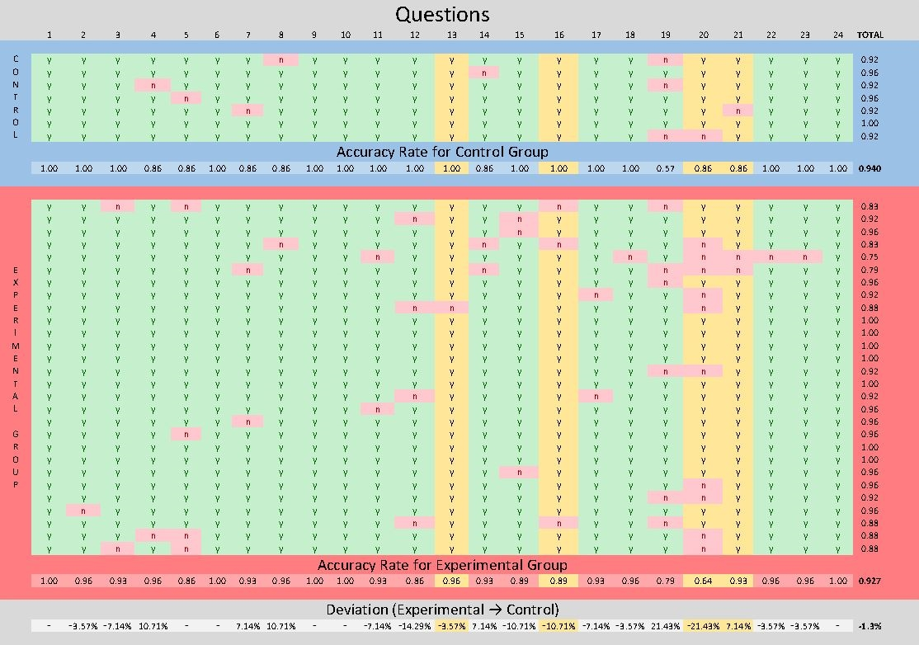**Table showing analysis of aggregated data**

**Graph comparing collective question accuracy between groups**

# Discussion

Upon analysis of the data, it is apparent that the accuracy of the responses for the trick questions (13, 16, 20 & 21 as indicated in the graph) of the experimental group are significantly lower than that of the control group. This is noticeable in question 20, with the accuracy rate being about 20% worse than the control group. Deviations of accuracy of the other trick questions compared to the control group are also quite large, indicating a trend.   
On the last column of the table, the average accuracy of the experimental group is also lower than the control group.

**In conclusion, all the findings presented support my hypothesis that repetition has a negative effect on one’s attention to detail.**

## Limitations

This experiment has several limitations which may have skewed the results.

1. There were not enough people participating in the control group to be able to compare the control with the experimental group. This created a slight difficulty in first understanding the correlation between both data sets. This can be seen in the accuracy rates for question 19, where for some reason, the control group had experienced a large decline in accuracy. If more control results could have been collected, ‘outlier’ values would be mitigated.
2. The puzzle was only performed 35 times, meaning that the data too will have ‘outlier’ values which would significantly affect the sets of results. More completed puzzles (hence more results) would reduce the impact of ‘outliers’
3. Another limitation is that the shapes that were being asked to select were cycled. Though this is another form of repetition, it requires the participant to keep paying attention to the question, which reduces the effectiveness of the trick questions. This implication was due to bad planning of the questions whilst creating the puzzle (and it took too much time to fix it).
4. Due to the nature of an unsupervised and online experiment, it is difficult to filter out falsified or spam results. In an attempt to counter this, results which had less than 60% overall accuracy were redacted. This may have however removed legitimate results. In the future, this experiment could be performed supervised, next to the participant.

# Appendix

## Puzzle game Page

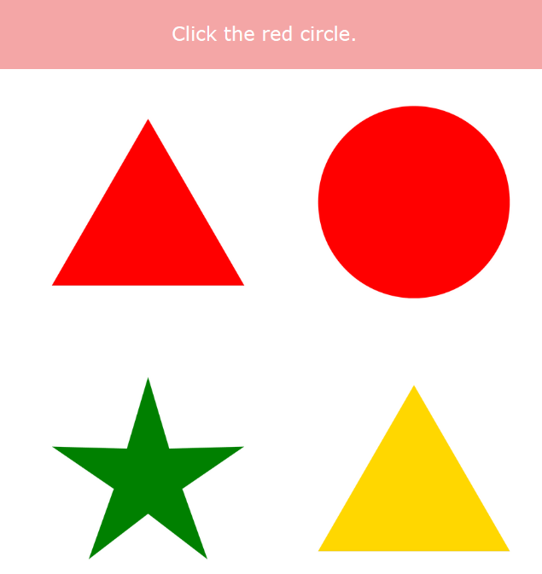 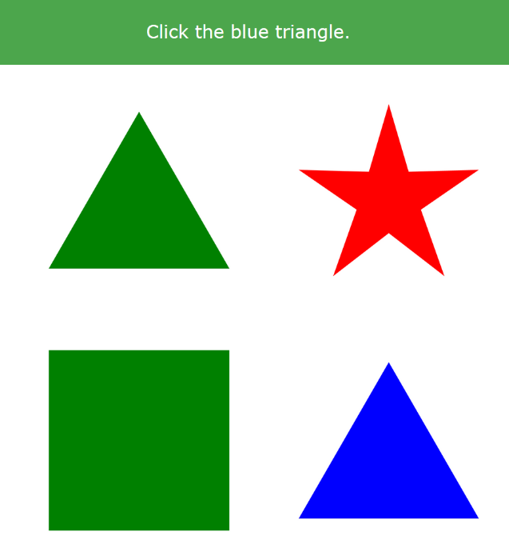

**Standard Question**

**Trick Question**  
 *Notice how the background is green, but the question asks for blue*

# References

S. Adam Smith. An Exploration of the Negative Effects of Repetition and Testing on Memory. (2016). The University of North Carolina. Available at: <https://campuspress.yale.edu/yrurp/files/2015/11/Smith2013-27rc78t.pdf>

Mulligan, N. and Peterson, D. (2013). The negative repetition effect. *Journal of Experimental Psychology: Learning, Memory, and Cognition*, 39(5), p.1403. Available at: <http://psycnet.apa.org/psycinfo/2013-05532-001/>